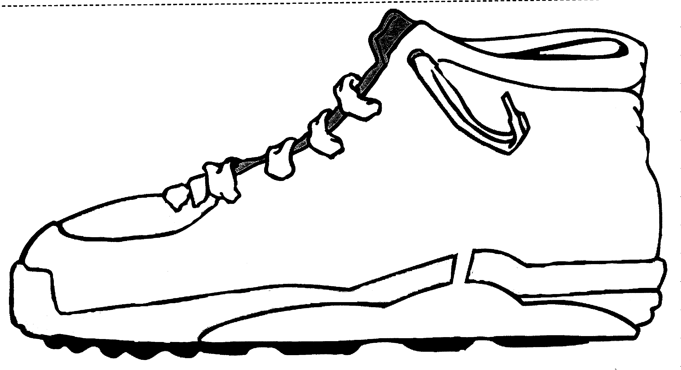
Where are you From?
Where are you going?
You will use this SHOE to record information about yourself.
You should be able to give your shoe to someone and they would be able to introduce you.
Sample Questions: What are your Likes and Dislikes, Background – Family, Born at, Dreams for the future, Hobbies, Sports, Good at!
Favorite Foods, Kinds of music, Special interests -
Be creative with colors, drawings and pictures. – You will cut this out and they will be posted on a Bulletin Board.

